Reporting Category 3: Biological Evolution and Classification
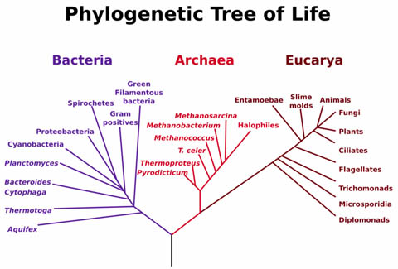
B.7A: Analyze and evaluate how evidence of common ancestry among groups is provided by the fossil record, biogeography, and homologies, including anatomical, molecular, and developmental.
What is common ancestry?
- Common ancestry is the concept that a group of closely related species are all descended with some modifications from the same ancestor.
- Descent with Modification is the idea that living species have descended (come from)—with changes due to adaptation and natural selection—from species that lived before them.

Evidence of Common Ancestry
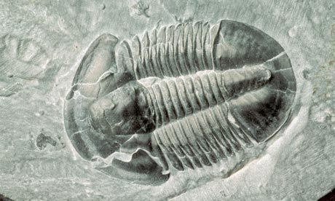
- Fossil Record
- Fossils are remains of ancient organisms that are preserved in Earth’s layered (sedimentary) rocks. The oldest fossils are bacteria that lived on Earth about 3.8 billion years ago. Although the fossil record is not complete, the general pathway of evolution (change) can be followed.
- The fossil record enables biologists to hypothesize about how different groups are related to one another. These hypotheses are used to make the tree of life, which shows the lines of descent that link different groups of organisms
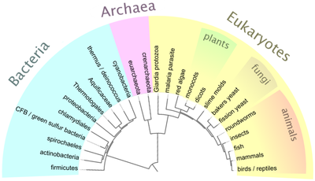
- Biogeography: the study of where species live now and where species and their ancestors lived in the past
- provides evidence how closely related species differentiated under different selection pressures.
- Ex: Darwin’s Finches show how many species can evolve from the same common ancestor through geographical isolation
- provides evidence as to how distantly related groups have evolved similar traits under similar selection pressures.
- Ex: grazing animals, such as cattle, zebras, and llamas, evolved on temperate grasslands in different parts of the world. Their biogeography suggests that many of their similar traits, such as teeth for grinding grass and long legs, evolved long after they diverged from a common ancestor.

- Homologies
- Anatomical Homologies
- Structures, such as forelimb bones, that show similarities between groups of organisms, are called homologous structures. The more similar the homologous structure, the more closely related the species.
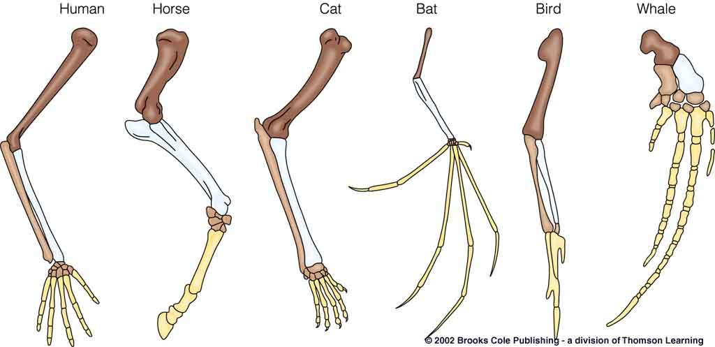

- Some species have homologous structures that have little or no function, called vestigial structures. The existence of vestigial structures in modern species suggests evolutionary links between these species and ancient ancestors in which these structures did have a function.
Ex: the presence of hipbones in dolphins, which do not have legs, indicates that
ancestors of these dolphins did have legs.
- Molecular Homologies
- By comparing DNA and amino acid sequences, scientists can determine whether or not organisms are closely related. Close relatives share more similarities in DNA and amino acids than do distant relatives.
- For example, the table below shows the similarities and differences in several species of insects. Based on the data, the screwworm fly and the silkworm moth are the least genetically related because they show differences in composition of 4 amino acids (cysteine, glutamic acid, glycine, and valine).
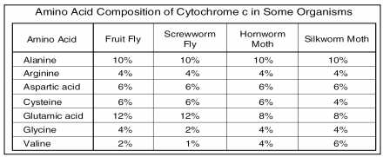

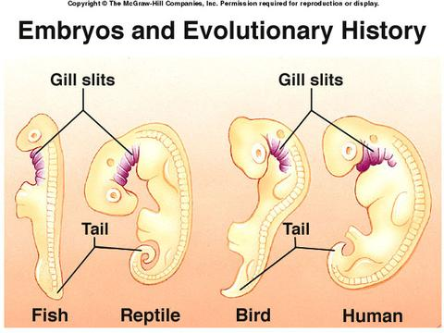
- Developmental Homologies
- Embryology- Studying organisms in their earliest forms of development also helps scientists see similarities and possible relationships between organisms.
  - For example, embryos of fish, reptiles, birds, and mammals look very similar. This pattern indicates evolutionary relationships among these species.

Check Your Understanding
- Why are homologous arm bones evidence for common ancestry among vertebrate groups?
- because the common ancestor likely passed the traits for arm bones to its descendents
- because the arm bones show how two closely related organisms can have different structures
- because the arm bones show how ancient organisms were more complex than modern organisms
- because the arm bones show that the fossil record is true and accurate
- Scientists have observed many close similarities in the DNA sequences of whales and dolphins. This observation is evidence for which idea?
- Whales are ancestors of modern dolphins.
- Whales and dolphins both evolved from a relatively recent common ancestor.
- Whales and dolphins are members of the same species.
- Whales and dolphins can breed with one another to produce a new species.

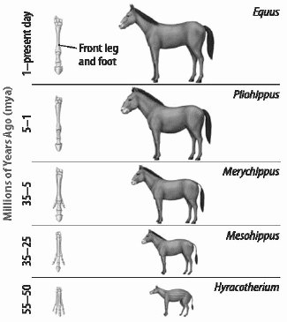
- What is suggested in this picture?
  - Horses have become smaller through time.
  - Horses have evolved to have more than one toe
  - Horses have smaller teeth now
  - Horses have evolved to have less toes now

- What are some of the differences between the various types of homologies- anatomical, developmental, and molecular?

B.7B Analyze and evaluate scientific explanations concerning any data of sudden appearance, stasis, and sequential nature of groups in the fossil record.

What are the scientific explanations concerning data of the sequential nature of groups in the fossil record?
- fossils are found in sedimentary rock
- deeper rock layers, and the fossils within them, are older than layers closer to the surface
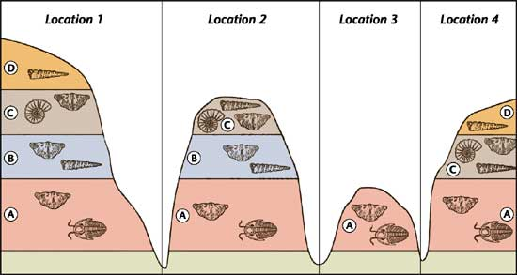
- scientists use index fossils—fossils of species that are easily recognizable, that lived during a specific geologic time span, and that had a wide geographic range—to help them decipher the fossil record.

- the process of adaptive radiation also explains the sequential nature of groups in the fossil record. In adaptive radiation, several diversely adapted species evolve from a common ancestor.
- occurs when a species is introduced to an unpopulated area, such as a recently form volcanic island.
- may occur when the environment changes suddenly and many species go extinct at once
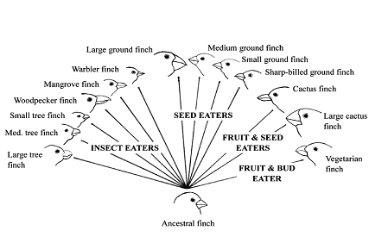
- the mass extinction that occurred 65 million years ago, during which all of the dinosaurs died, allowed for the adaptive radiation of mammals.

What are the scientific explanations concerning data of sudden appearance in the fossil record?
- Fossils that represent a new species may appear suddenly in the fossil record. To explain this, scientists have inferred that their immediate ancestors are missing from the fossil record.
- The fossil record is incomplete for many reasons.
- Only a small fraction of organisms die in ways, or in places, that enable them to become fossilized.
- Natural geologic processes such as erosion and mountain building can change or reorder sedimentary rock layers. Where these processes occur, the fossil record may be confused or even destroyed.
- Another explanation for the sudden appearance of species is a model of evolution called punctuated equilibrium. Punctuated equilibrium describes a pattern of evolution in which long stable periods are interrupted by brief periods of more rapid change.
- the amount of genetic change increases rapidly
- may occur when small populations become isolated from larger ones
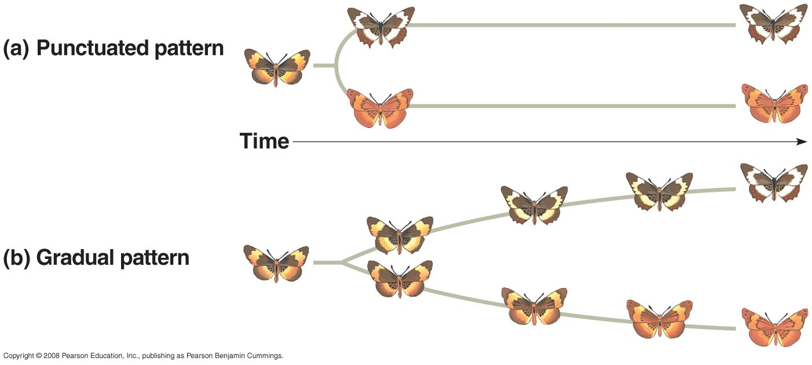
- may occur after mass extinctions when surviving organisms fill new niches.

- Another model of evolution is called gradualism. Gradualism is the evolution of a species by gradual accumulation of small genetic changes over long periods of time.
- explains the appearance of new species as a slow and steady process taking millions of years.

What are the scientific explanations concerning data of stasis in the fossil record?
- Stasis occurs when the structure of a species in the fossil record does not change over a long period of time (through genetic changes may still be occurring).
- horseshoe crabs are an example of organisms whose structure have stayed the same for a very long time.
- stasis in the fossil record is linked to the evolutionary model of punctuated equilibrium

Check Your Understanding
- A scientist discovers a fossil of an ancient reptile. The reptile species appears suddenly in the fossil record. According to the evolutionary model of punctuated equilibrium, what is the most likely explanation for its sudden appearance?
- The fossil record concerning the species is complete.
- The species evolved relatively quickly from its immediate ancestor.
- The species evolved very slowly and gradually over millions of years.
- Fossils readily form in the region where the species lived.

- How do scientists explain the incompleteness of the fossil record?
- Geological events such as erosion might confuse or even destroy parts of the fossil record.
- Evolution occurs only after a species has existed for millions of years, so many fossils have been lost
- The fossil record contains only animals, no plants.
- Fossils are the remains of organisms that have recently died.
- Sixty-five million years ago, all dinosaurs and many other species went extinct. The adaptive radiation of mammals helps explain which observation of the fossil record after that mass extinction?
- a rapid increase in mammal diversity
- stasis among certain mammal species
- a gradual decrease in mammal diversity
- a rapid decrease in the size of mammals

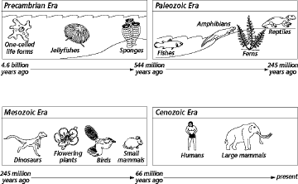Figure 14-1
According to Figure 14-1, what was the earliest form of multicellular life on Earth?

- Invertebrates
- Fish
- Reptiles
- Land plants

- According to the diagram in 14-1, the correct chronological order of organisms as they developed are-
- Birds, dinosaur, jawed fish, prokaryotes
- Dinosaurs, birds, jawed fish, prokaryotes
- Prokaryotes, jawed fish, birds, dinosaurs
- Prokaryotes, jawed fish, dinosaurs, birds

- While looking for fossils on an eroded hillside, you discover fossil coral and fish in one layer. In a layer just above, you find the fossil imprint of a fern frond and some fossil moss. Assuming the rock has not been disturbed, which of the following is the most probable conclusion?

- A saltwater sea had changed to a freshwater lake long ago.
- The area had been under sea until recently.
- In ancient times a sea had been replaced by land.
- A forest once grew but was replaced by sea water.

B. 7C: Analyze and evaluate how natural selection produces change in populations, not individuals.
What is natural selection?
- A population is a group of individuals of the same species who interbreed.
- A variation that makes an organism more successful in its environment is called an adaptation. Individuals with adaptations that help them survive and reproduce in their environment have high fitness.
- Fitness refers to an organism’s ability to survive and reproduce in its environment.
- Natural Selection is a process in which organisms with adaptations best suited to their environment leave more offspring than other organisms. Because these organisms produce more offspring, their genetic variations become more prevalent in a population and the population changes, or evolves.
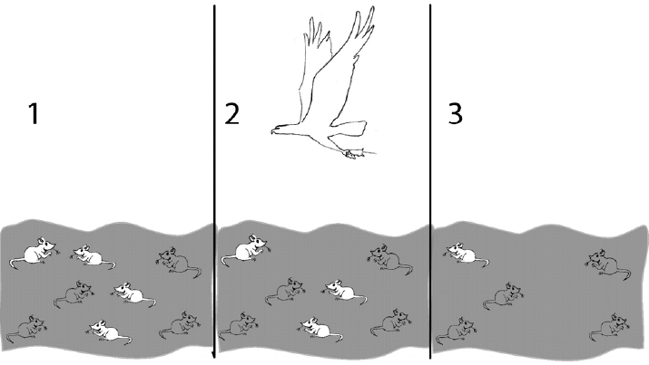

How does natural selection produce changes in populations, not individuals?
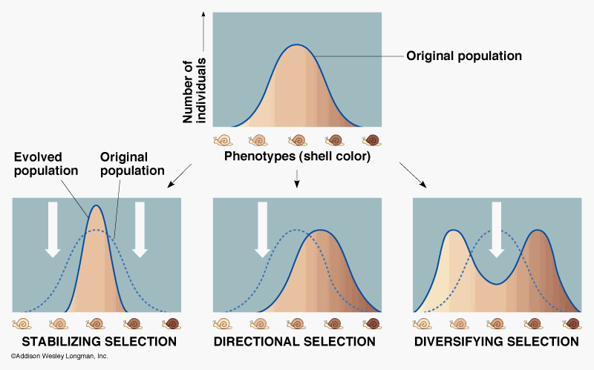

- 3 Ways:
- Stabilizing Selection: occurs when extremes in phenotypes give individuals in the population a disadvantage. Often, these traits are controlled by multiple genes.
- Ex: The lightest and darkest shells are selected against. Those in the middle survive best
- Directional Selection: occurs when individuals with a particular phenotype have an advantage in their environment. Often, a single gene controls the trait.
- Ex: darker shell is more selected for than the lighter shell
- Disruptive (Diversifying) Selection: occurs when extreme phenotypes for a trait are adaptive. Acts against individuals with an intermediate phenotype.
- Ex: The lightest and darkest shells are selected for, and those in the middle are selected against.

Check Your Understanding
- Which of the following best explains how natural selection occurs?
- Individuals acquire traits during their lives that they pass on their offspring.
- Only individuals with adaptive traits want to reproduce and pass their traits to offspring.
- Traits are genetically based, and individuals with adaptive traits are more likely to survive and reproduce and pass on their traits to offspring.
- When organisms reproduce, they pass along only their most useful traits to offspring.

- When investigating shell color of a species of snail found only in a remote area seldom visited by humans, scientists discovered the distribution of individuals that is shown in the graph in Figure 15-1. Based on the information shown in the graph, what form of selection is the snail population undergoing?
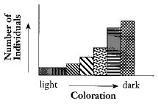
- Stabilizing selection
- Artificial selection
- Directional selection
- Disruptive selection

B.7D: Analyze and evaluate how the elements of natural selection, including inherited variation, the potential of a population to produce more offspring than can survive, and a finite supply of environmental resources, result in differential reproductive success.

What causes inherited variation among individuals in a population?
- Inherited variation refers to the genetic differences among individuals in a population, such as body size or fur color.
- Inherited variation can be caused by mutations in DNA, crossing-over during meiosis, and independent assortment of chromosomes. Variation can also be introduced when individuals migrate from one population to another and mate.
- Two components of inherited variation are genotype and phenotype. Knowing the frequency of alleles and phenotypes in a population is important for understanding how natural selection could affect the evolution of a population.
- Ex: a sample population of mice is made up of 48% heterozygous black mice (Bb), 16% homozygous black mice (BB), and 36% homozygous brown mice (bb). Sixty-four percent of the population has black fur. However, the brown fur allele occurs more frequently in the population that the black fur allele (b = 60%; B = 40%).

What contributes to differential reproductive success?
Natural selection explains how species evolve, or change, over time. Natural selection is based on several key principles:
- Overproduction- Populations tend to produce more offspring than can possibly survive. When this happens, the likelihood increases that some offspring will reach reproductive age.
- Inherited variation- Each individual has its own traits.
- Competition- Because resources are finite, or limited, there is a struggle for survival.
- Selection- The individuals that win the struggle for survival will be able to reproduce.

In summary, when organisms with favorable variations (helpful traits) for a particular environment survive and reproduce, they pass the favorable variations (helpful traits) to their offspring. Organisms with less-favorable variations (not helpful traits) are less likely to survive, and therefore less likely to mate. If they do not mate, they will not pass on their traits, and over time we will see fewer and fewer individuals with that trait.

Check Your Understanding
- Which of the following best describes how frequencies of alleles are related to environmental conditions?
- If the environment changes, then new alleles will emerge and become more frequent in a population.
- If the environment changes, the frequency of alleles that give individuals an advantage in the new environment will increase.
- Environmental changes occur in response to changes in allele frequencies.
- Genetic mutations in individuals can give the rest of the population a survival advantage.
- How can an environmental pressure such as seed scarcity affect the evolution of a population of birds?
- The population could evolve a higher frequency of alleles for a phenotype that would enable the birds to eat a wider range of seeds.
- The population of birds would likely remain unchanged because of the environmental stress.
- The population would likely migrate to a different location in search of a new food source.
- The population would likely have more mutations in genes that carry traits for efficiency of seed collection.
- Why do some individuals have more reproductive success than others in a population?
- Reproductive success is equal for all individuals within a population.
- Individuals with traits that lead to increased fitness in their environment survive to adulthood and are more likely to reproduce than individuals that lack these traits.
- Individuals that are less fit for their environment mate more frequently in order to pass on their genes as quickly as possible.
- Individuals with traits for increased reproductive rates are less likely to survive in the environment.

- Which is an example of camouflage?

- The viceroy butterfly’s colors match the monarch butterfly’s color.
- The leafy sea dragon looks more like a plant than an animal.
- The thick feathers of the great horned owl make it a silent flier.
- A group of macaws isolated on an island have uniquely shaped beaks.

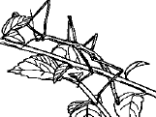
- What type of adaptation is shown in Figure 15-2?

- Homologous structure
- Mimicry
- Artificial selection
- Camouflage

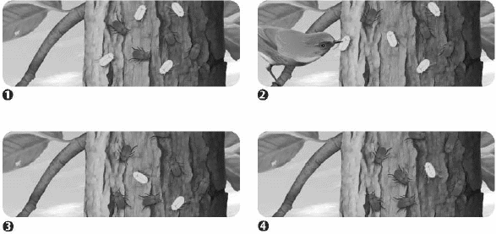
- What does this sequence illustrate?

- How camouflage results in variation.
- How selective breeding results in
adaptation.
- How variation results in an adaptation.
- How mimicry results in variation.

B.7E: Analyze and evaluate the relationship of natural selection to adaptation and to the development of diversity in and among species.

What is the relationship of natural selection to adaptation?
- Remember that an adaptation is a heritable trait that increases an organism’s ability to survive and reproduce in an environment. An organism’s genes determine its adaptations.
- Due to natural selection, individuals with adaptations that give them an advantage over other individuals in the same environment are more likely to reproduce and pass the adaptations to their offspring.
What is the relationship of natural selection to the development of diversity in a species?
- Individuals within a species vary genetically.
- Natural selection cannot change the genetic diversity of a species or population, but the outcome of natural selection may result in a change in frequency of the genes that already exist.
- Ex: polar bears could not respond to a warmer, less snowy Arctic by producing thinner or brown fur. But if the genes already exist in the population, they will likely be selected for.
What is the relationship of natural selection to the development of diversity among species?
- Species diversity refers to the number of species that exist at a given time.
- Natural selection and many other factors have a role in speciation, the formation of a new species.
- Speciation
- Tortoises of the Galapagos Islands can be used to describe how speciation may occur. At some point in time, there was one species of tortoise living on one island. There was genetic diversity within that one population. An event occurred, perhaps a storm that stranded some tortoises on a different island. These individuals started a new population in a slightly different environment. Over time, the two populations were subjected to different pressures from the environment, and the genetic variation increased.
- Once genetic variation reaches a point at which individuals from the different populations cannot interbreed and produce offspring, the populations become different species.
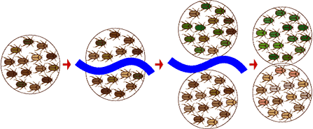

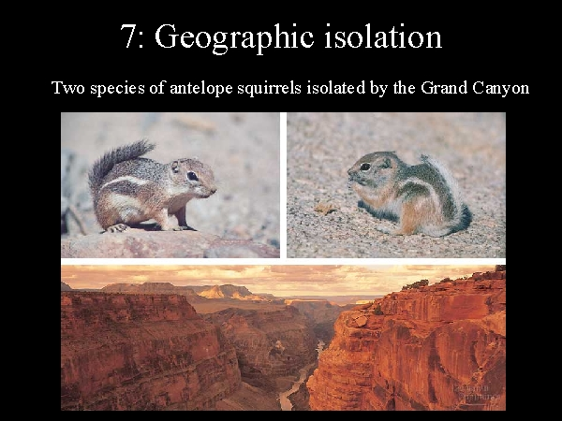
- Reproductive Isolation occurs when members of a population no longer interbreed.
- Geographic Isolation occurs when a physical barrier such as a body of water or a mountain range separates members of a population.
- ex: squirrels separated by a mountain
- Behavioral Isolation occurs when members of a species develop different behaviors that interfere with their ability to interbreed.
- ex: birds with different mating songs don’t recognize each other to mate.
- Temporal Isolation occurs when species breed at different times of the year, so they cannot reproduce with each other.
- ex: flowers blooming at different times of year

Check Your Understanding

- For many decades, doctors prescribed penicillin to fight bacterial infections. As explained by natural selection, how did so many bacterial populations become resistant to the original form of penicillin?
- The presence of penicillin was an environmental pressure that selected for bacteria that were resistant to it.
- The use of penicillin induced mutations that promote penicillin resistance.
- Different bacterial species evolved due to reproductive isolation.
- Different bacterial species evolved due to geographic isolation.

- In a mountain range, a valley forms that separates a population of squirrels. One side of the valley receives far less rainfall than the other side of the valley. At first the population of squirrels on the drier side struggles. But eventually it grows and flourishes. A severe drought hits the entire region and the population of squirrels on the rainier side of the valley dies, while the other population is largely unaffected. What is the best explanation for this sequence of events?
- The original intact population of squirrels had no alleles for resistance to drought.
- By chance, the population that ended up on the drier side of the valley had a high frequency of an allele that provided resistance to drought.
- Living on the drier side of the valley caused the squirrels to acquire a genetic variation that allowed them to be resistant to drought.
- Temporal isolation changed the genetic variations of the two populations.

- A certain species of plant lives on both sides of a river. Over thousands of years, the river grows wider and the plants evolve into two different species. What is this an example of?

- Land bridges
- Mass extinction
- Geographic isolation
- Change in climate

- Explain the difference between temporal isolation and behavioral isolation.

B. 7F: Analyze and evaluate the effects of other evolutionary mechanisms, including genetic drift, gene flow, mutation, and recombination.

How does genetic drift affect evolution of species?
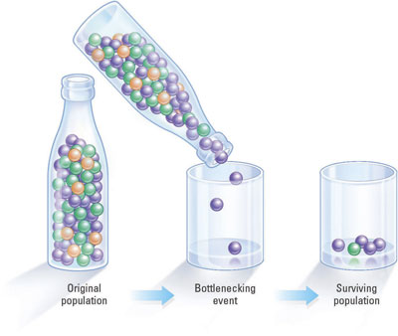
- Genetic drift is an evolutionary mechanism in which allele frequencies change in a population.
- Allele frequencies do not change due to selective pressures. Instead, the changes may be due to a natural disaster, such as a flood or forest fire, that randomly eliminates members of the population.
- A change in allele frequency is called the bottleneck effect.
- Genetic drift may also occur if a small number of individuals are separated from a larger population. The gene pool of this small population could be very different from that of the larger population. This change in allele frequency is called the founder effect.

How does gene flow affect evolution of species?
- Gene flow occurs when the genes of one population flow to a different population.
- can happen if members of a species arrive in a new habitat and mate with members of the existing population.
- the genes of these new members may cause a shift in allele frequency of the existing population
- gene flow will be low if there is little immigration (addition of members) or emigration (loss of members)
- gene flow increases the genetic variation within populations, but reduces the genetic differences from one population to another.
- if two populations of a species are isolated geographically, there will be a lack of gene flow between the populations. Eventually, the populations might evolve into separate species.

How do mutations and recombination affect evolution?
- Genetic mutations give individuals differences in traits that may be beneficial, may be harmful, or may have no effect in a particular environment.
- With mutations, it is important to understand that the environment can affect the rate of mutation, but it can’t cause a particular mutation to occur.
- Mutations are random and exist in individuals before evolutionary mechanisms can act on them.
- Recombination is another source of heritable variation and occurs for two main reasons:
- Independent Assortment: remember that during meiosis, each chromosome in a pair moves independently into a new gamete
- Crossing-Over: which also occurs during meiosis, is the exchange of corresponding segments between two homologous chromosomes. Crossing-over changes the way that genes are linked onto chromosomes, allowing for new combinations of alleles to be passed to offspring.

Check Your Understanding
- Which of the following mechanisms of evolution usually causes an increase in genetic diversity within a species?
- competition
- genetic drift
- mutation
- gene flow
- A fire kills all but a few of the deer that live in a forest. The surviving deer have a significantly different genetic makeup than did the average deer in the original, larger population. What best describes the evolutionary changes that will likely occur to the deer population?
- Selective pressures caused advantageous traits to become more common in the population.
- Selective pressures changed the population in random ways that may not be to the deer’s advantage.
- Genetic drift has altered the deer population due to the bottleneck effect.
- Genetic drift has altered the deer population due to the founder effect.

- Explain how mutations can be a mechanism of evolution.

- Why might a species that has 94 chromosomes per cell be able to evolve more quickly than a species that has 12 chromosomes?

B.7G: Analyze and evaluate scientific explanations concerning the complexity of the cell.
What do scientists think ancient cells were like?
- microscopic fossils that resemble bacteria have been found in rocks more than 3.5 billion years old.
- first cells lived when Earth’s atmosphere lacked oxygen (anaerobic environment)
- over time, processes such as photosynthesis and cellular respiration developed
- photosynthetic bacteria were the first organisms to perform photosynthesis
- photosynthesis may have increased oxygen levels so much that oxygen became more prominent in Earth’s atmosphere, making it possible for organisms who rely on oxygen for cellular respiration to exist on land.

What are some scientific explanations for how the complexity of cells has changed over time?
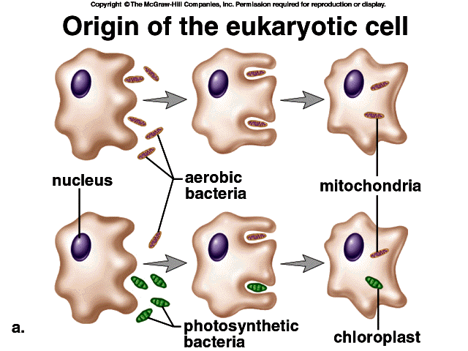
- Endosymbiotic Theory: states that some organelles in eukaryotic cells formed from symbiotic relationships between early eukaryotic cells formed from symbiotic relationships between early eukaryotes and prokaryotes. Endosymbiosis is a process in which one organism lives inside another organism to the benefit of both.
- over time, the endosymbionts evolved into organelles that we now observe as mitochondria.
- in another endosymbiotic process, free-living photosynthetic bacteria became chloroplasts.

- Observations that support the theory that these organelles evolved from free-living cells:
- mitochondria and chloroplasts have their own DNA and their own mechanisms for making proteins, including ribosomes
- they are surrounded by double membranes
- they replicate within the cell by binary fission

Check Your Understanding
- Which of the following is evidence for the endosymbiotic theory?
- Mitochondria and chloroplasts can live outside the host cell.
- Mitochondria and chloroplasts perform specific functions within the cell that other organelles do not perform.
- Mitochondria and chloroplasts do not have a cell wall.
- Mitochondria and chloroplasts have their own DNA.

- Which of the following best describes early cellular life?
- The first cells were photosynthetic and did not require oxygen.
- The first cells were anaerobic and broke apart small molecules for energy.
- The first cells took in oxygen from fresh water.
- The first cells were very similar to present-day eukaryotic cells.

B.8A: Define taxonomy and recognize the importance of a standardized taxonomic system to the scientific community
Definition:
- The branch of biology that is concerned with grouping and naming organisms based on their similarities.
- Scientific names have two parts (binomial nomenclature) – Genus and species.
Ex: Homo sapiens- Human

B.8B: Categorize organisms using a hierarchical classification system based on similarities and differences shared among groups
Hierarchical Classification:
- Scientists organize organisms into the following categories:

- Domain (most general)
- Kingdom
- Phylum
- Class
- Order
- Family
- Genus
- Species (most specific)
- Dearest
- King
- Philip
- Came
- Over
- For
- Great
- Soup

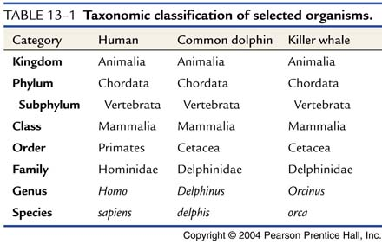
- The more taxons (groups) organisms share, the more closely related they are. Notice below that the common dolphin and the killer whale are more closely related to each other than they are to the human. Although the three have the same kingdom, phylum and class, the human has a different order.

B.8C: Compare characteristics of taxonomic groups, including archaea, bacteria, protists, fungi, plants, and animals
Domains:
- There are three domains: Archae, Bacteria, and Eukarya. Archae and Bacteria contain prokaryotic organisms (which lack nuclei and other membrane-bound organelles). Members of Eukarya are all eukaryotic (contain a nucleus and other membrane-bound organelles).

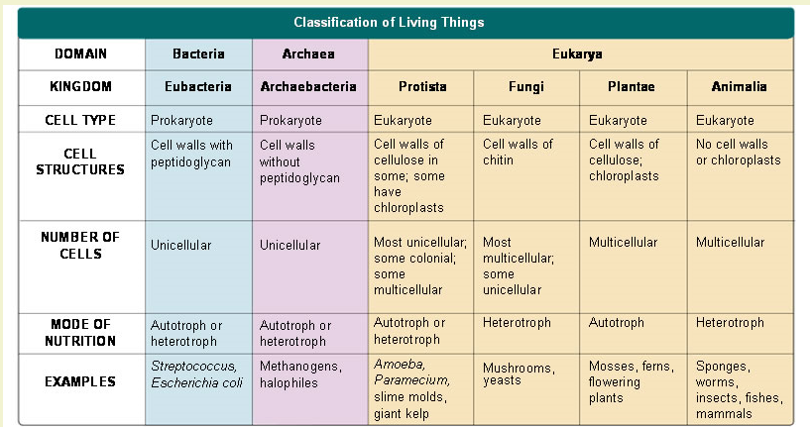

Check Your Understanding

- The Ferruginous bird (Buteo regalis) is most closely related to which of the following?
- Flesh-footed Shearwater (Puffinus carneipes)
- Fulvous Whistling Duck (Dendrocigna bicolor)
- Fork-tailed Storm Petrel (Oceanodrama furcata)
- Rough-tailed Hawk (Buteo lagopus)

- An organism that is heterotrphic, has a nucleus, and cell walls made of chitin probably belongs to which kingdom?
- Eubacteria
- Fungi
- Protista
- Plantae

- Which of the following would not be found in the kingdoms Protista, Fungi, Plantae, or Animalia?
- Eukaryotes
- Prokaryotes
- Multicellular organisms
- Unicellular organisms
- Why do scientists use binomial nomenclature to name a species?

- What is this system of classification based on?

- Organize these taxon from most general to most specific:
  - Phylum
  - Order
  - Species
  - Domain
  - Kingdom
  - Class
  - Family
  - Genus

- What is the proper method of writing a binomial name?

